Documentation
• What develop and run environment are used, e.g. what tools will be used for design and development. How will you set up server-side environment and database?
o Identify any ambiguity in the specifications and requirements and clarify them before designing the application.
The application must required develop with PHP and MySQL as database, the SMT Movie Rental provides an MS-Excel file contains all the movies data and we need to input all the data into MySQL. The application should have function to access the movies database and search by different ways.
For UI design will use Canva for UI prototype, app will develop and run at windows system, will use notepad++ and MySQL database to develop to the application.
Webmin will be the server-side environment and the MySQL will be setup inside Webmin.
• Design the application
o Produce a prototype of the user interface in a visual format as an image(s) or template web site. Include website navigation hierarchy.
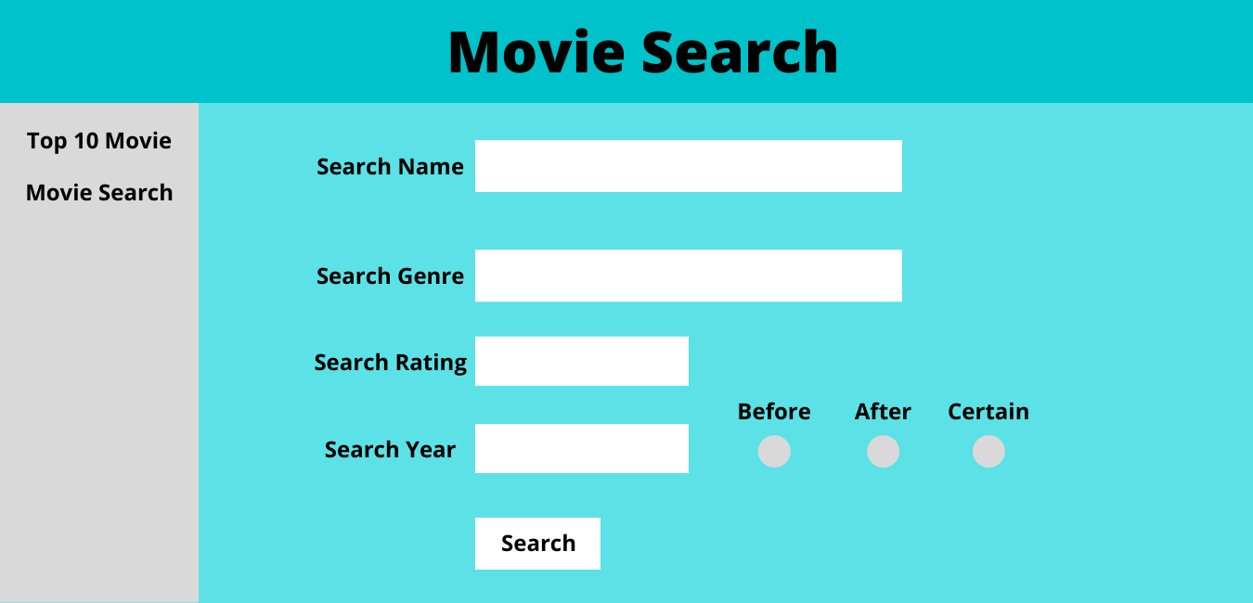
o Create the database design and validate it against the spreadsheet data, e.g. database structure.
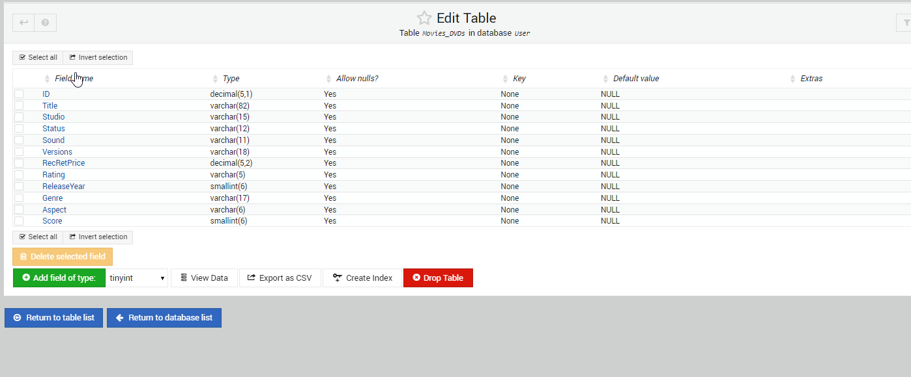
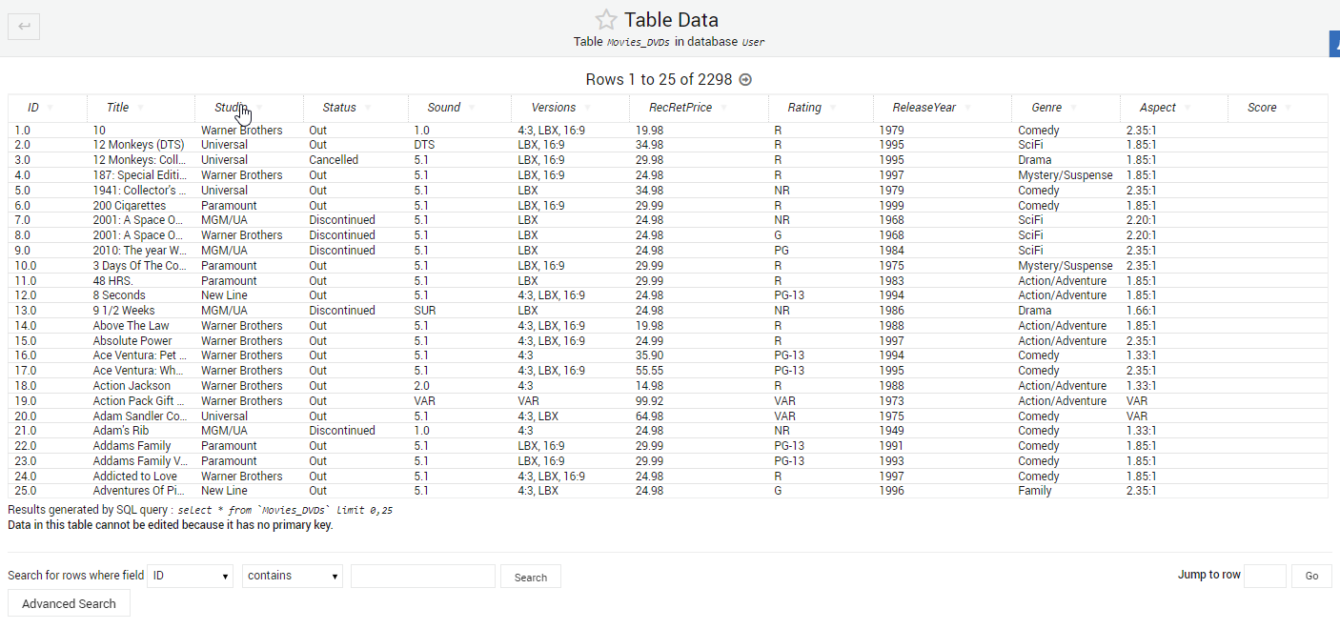

o Design appropriate forms for user inputs and data display.
Input
Display
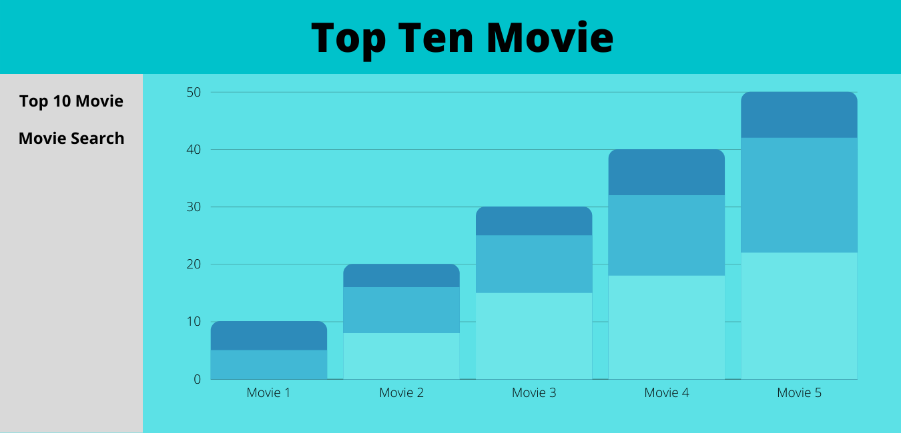
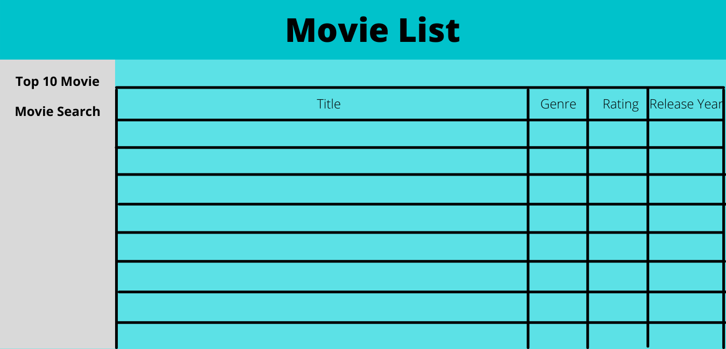
o List the HTML forms elements and CSS for your design.
HTML
- Top 10 Movie
- Movie Search
CSS
- Background color: cyan
- Font color: black
- Font weight: Bold
- Font size: 15
o Design separate web modules/components, e.g. header, footer modules to be included
PHP
<head>
<link rel="stylesheet" href="index.css">
</head>
<nav>
<h2>
<a href="topten.php">Top 10 Movies</a>
<a href="index.php">Movie Search</a>
</h2>
</nav>
<body>
</body>
CSS
body {
font-size: 15pt;
font-family:serif;
color: black;
background-color: cyan;

}
h1 {
font-size: 15pt;
font-family: serif;
font-weight: bold;
}
o Save your design separately before developing the application.

Testing
• Create test documentation
o Test your code against the PEAR code standard with an appropriate static analysis tool, e.g. PHP_CodeSniffer
Connect
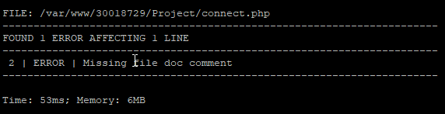
Index
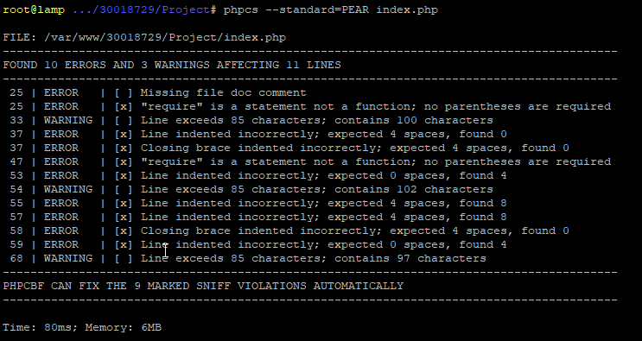
Search movies
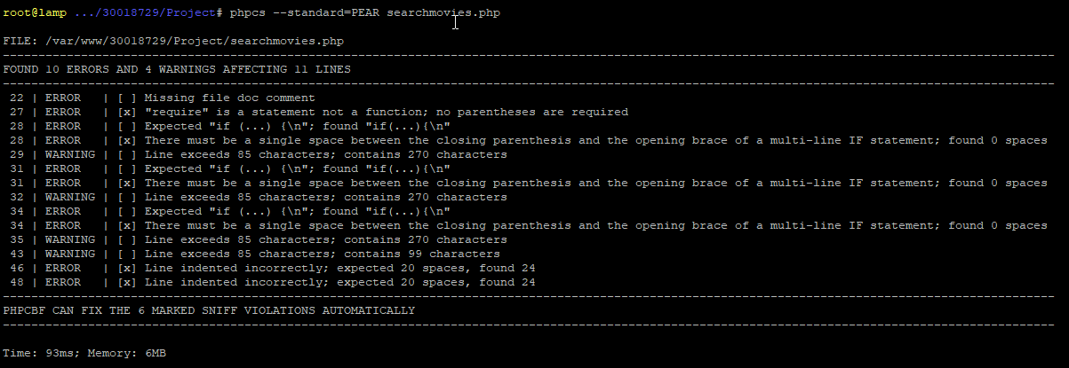
Top ten
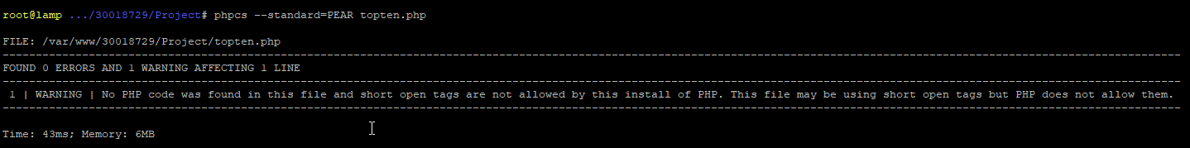
Top Ten graph
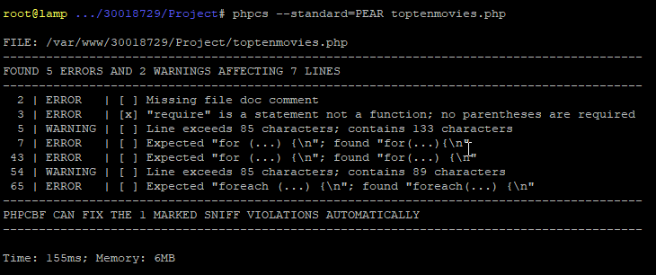

o Fix the errors detected. E.g. you can use the PHP Code Beautifier utility.
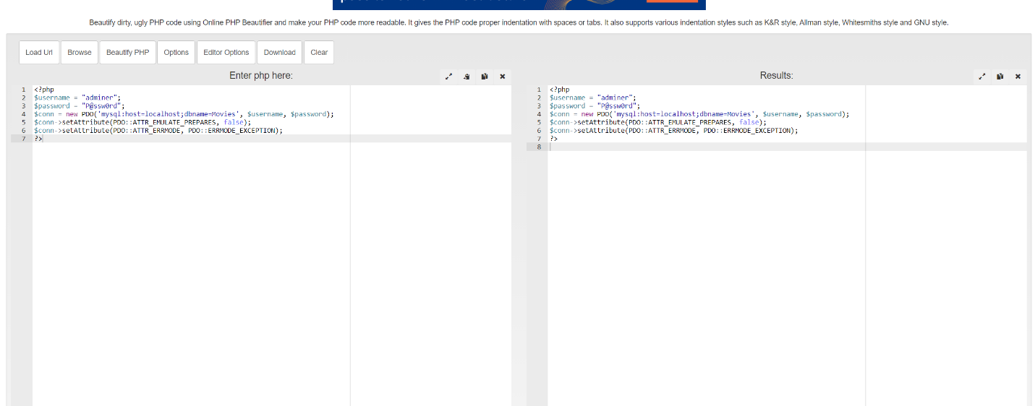
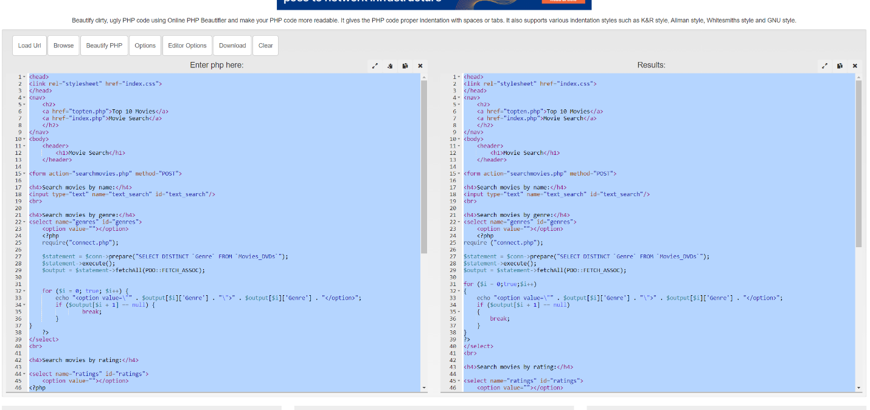
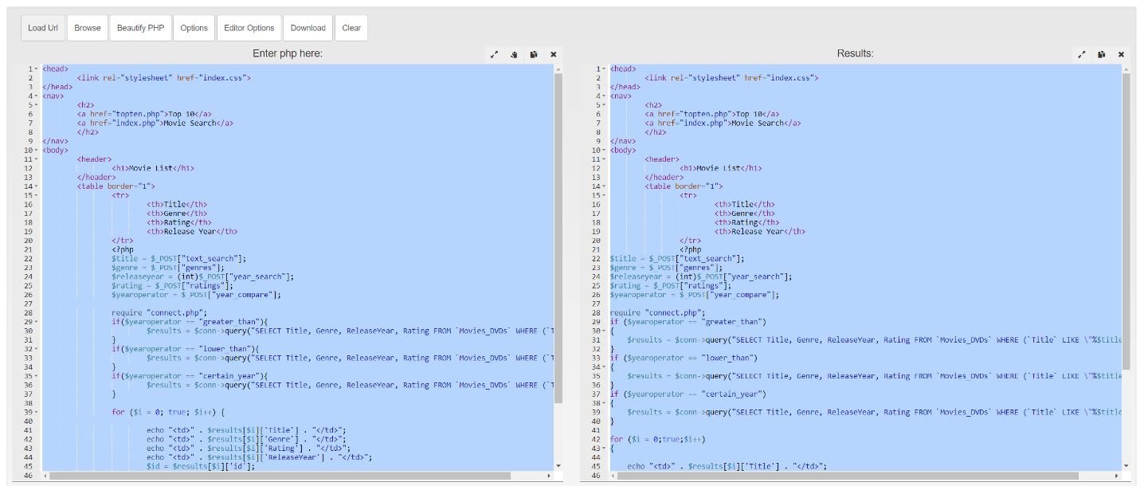
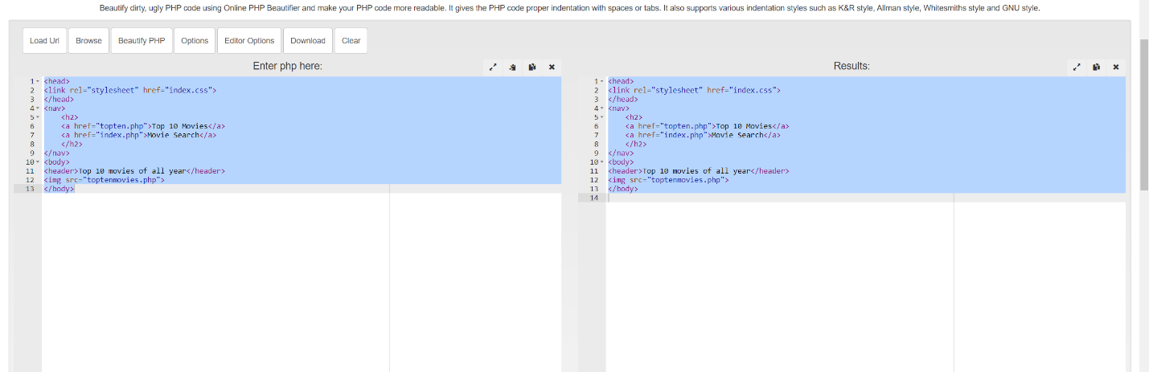
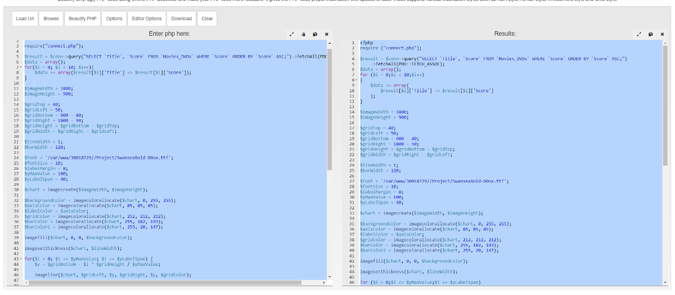

o Demonstrate software risk analysis and add this section to the report.
Test input value, if user input invalid value the movie list shouldn’t show anything.
Make sure size of the graph is suitable for the website or it will out of bounds .
o Identify potential software risks or problems, e.g. Possible invalid user inputs that cause unexpected behaviour? Is requirements incomplete? Security issues?
Requirement is complete, if user type invalid value and search the movie list won’t show anything.

o Test and validate with sample inputs with screenshots.
Name
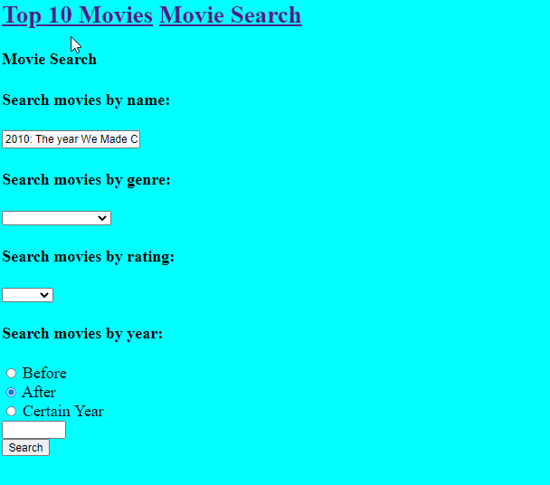
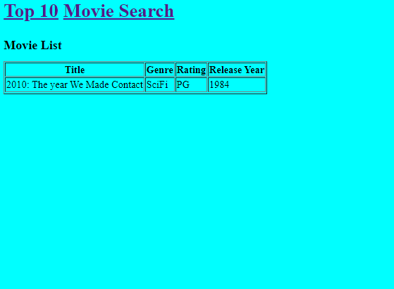
Genre
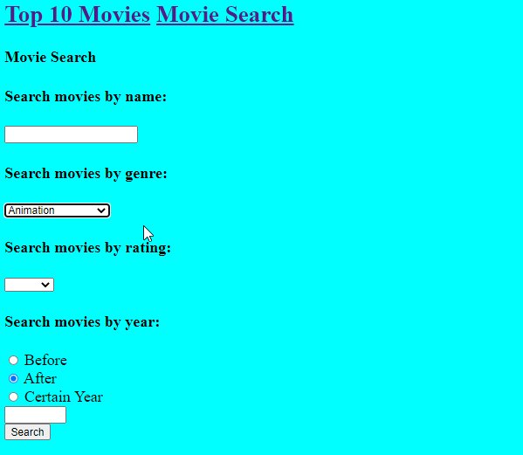
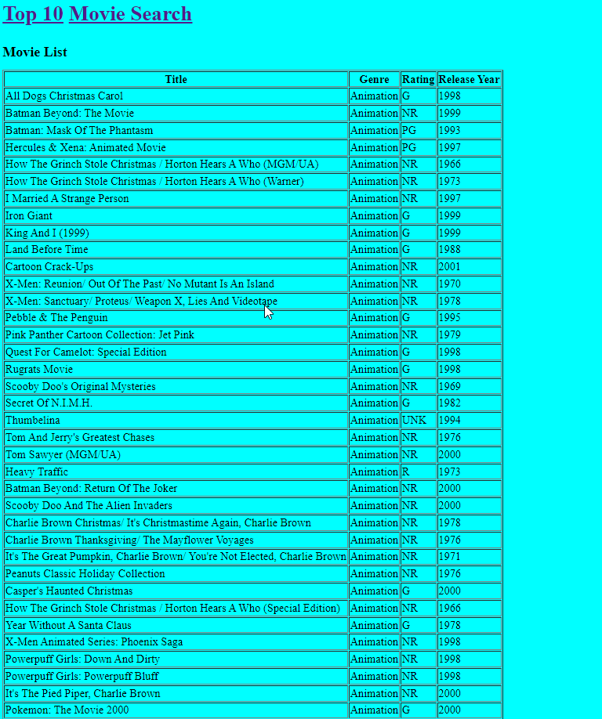
Rating
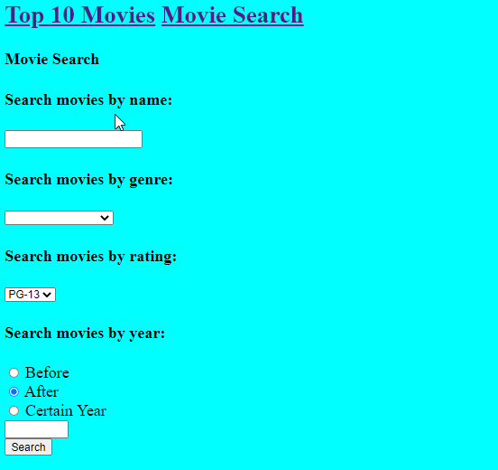
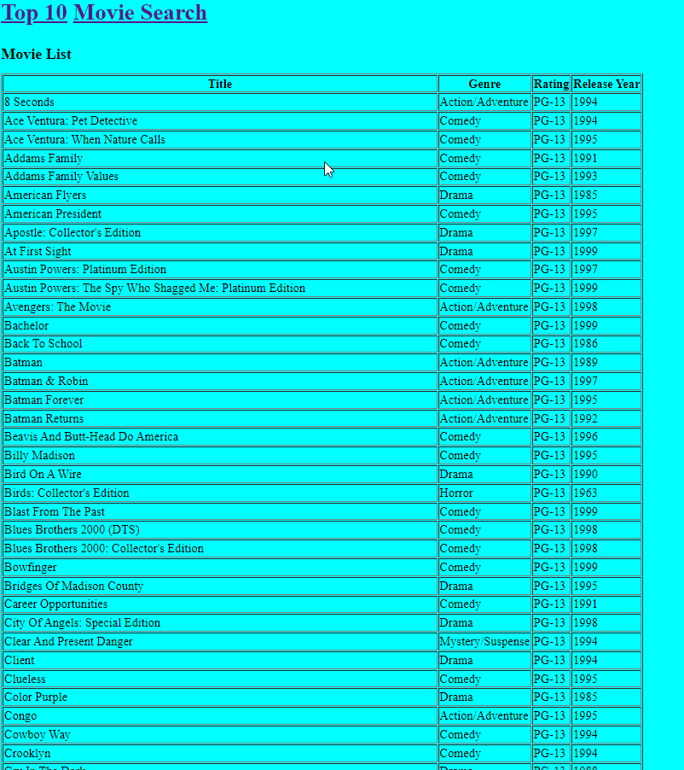

Year
Before 1999
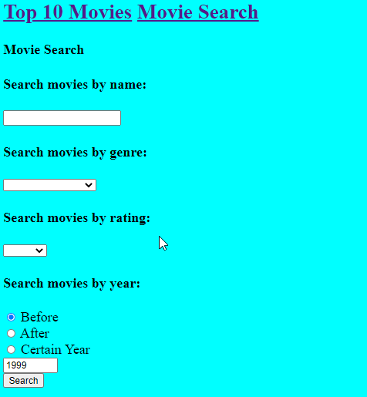
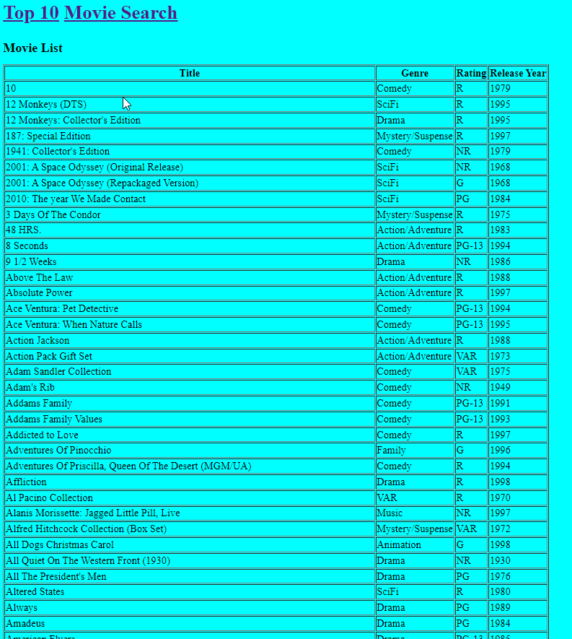

After 1999
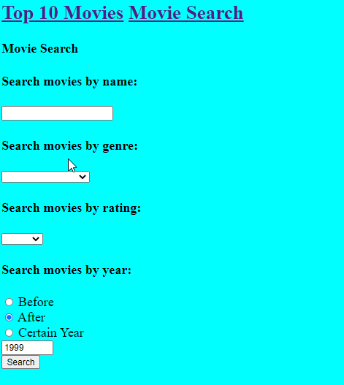
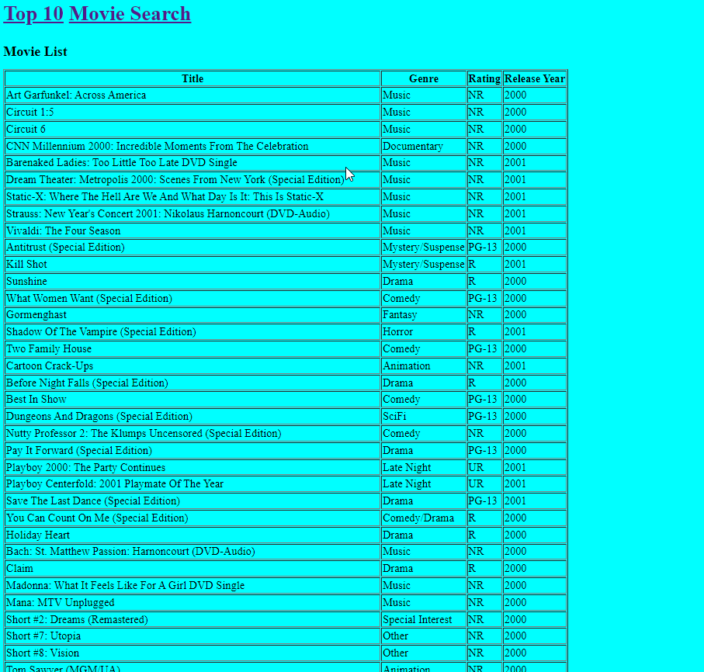

Certain Year 1999
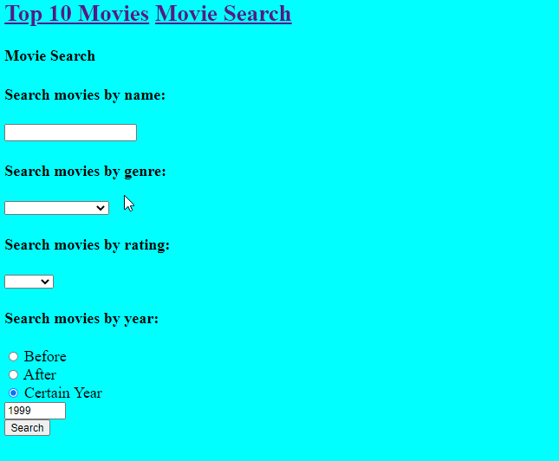
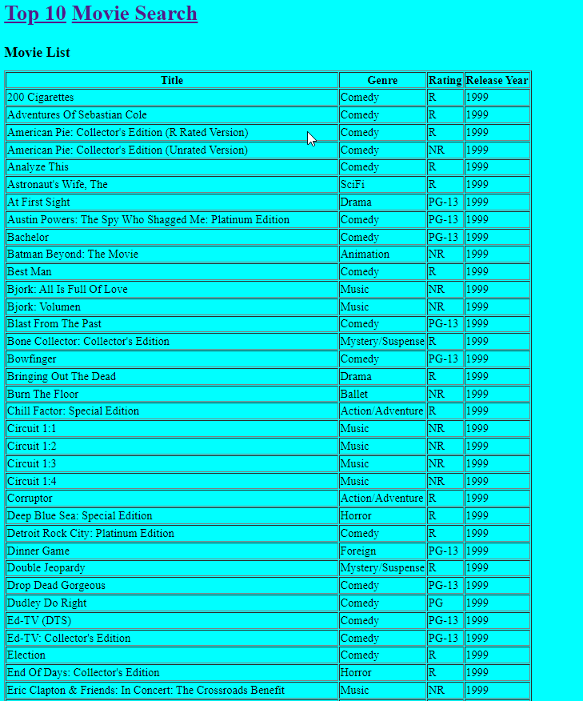

o Test the logic of the contents of the application.
Invalid input
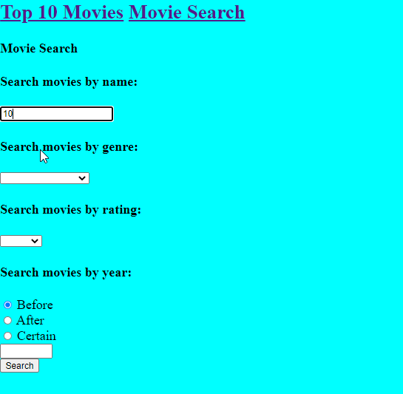
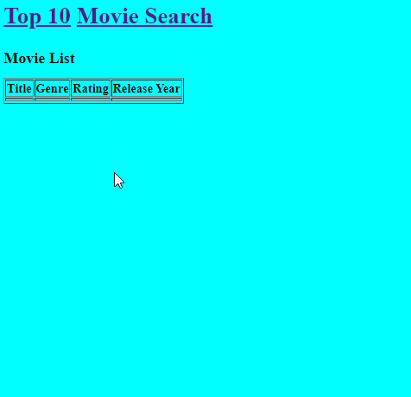
Valid Input

Year
Before 1999

After 1999

Certain Year 1999

o Validate the consistency between the code and the software design. Include testing in various browsers, e.g. Chrome and Firefox.
Chrome
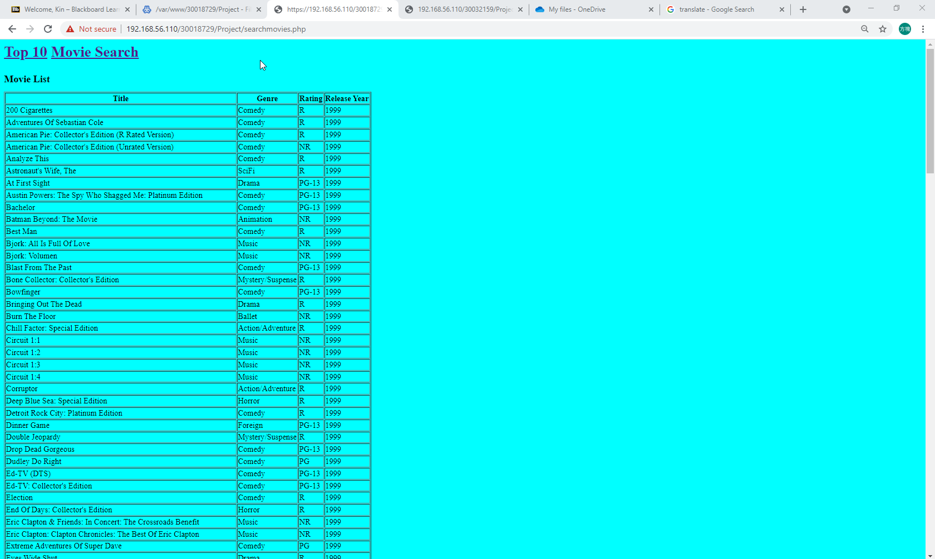
FireFox
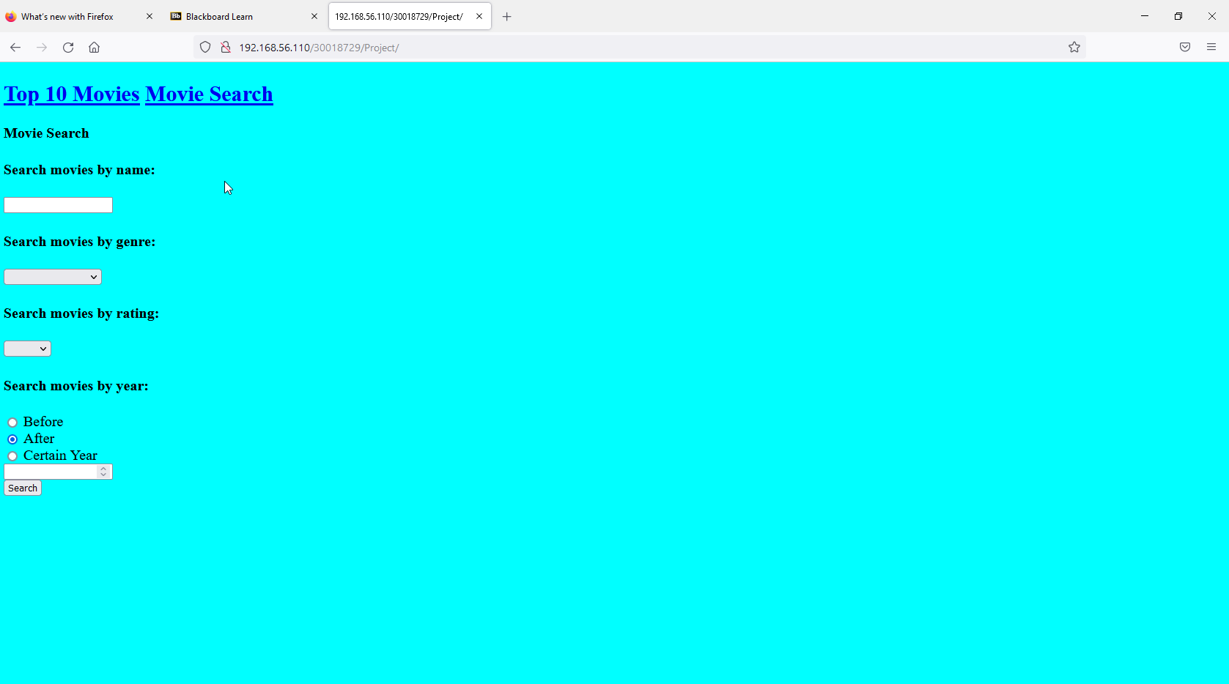
o Provide evidence that you adjusted your application base on the test.
Database not working
Reason: wrong name
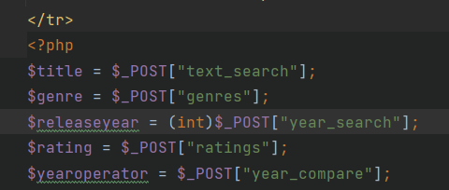
Underline missing
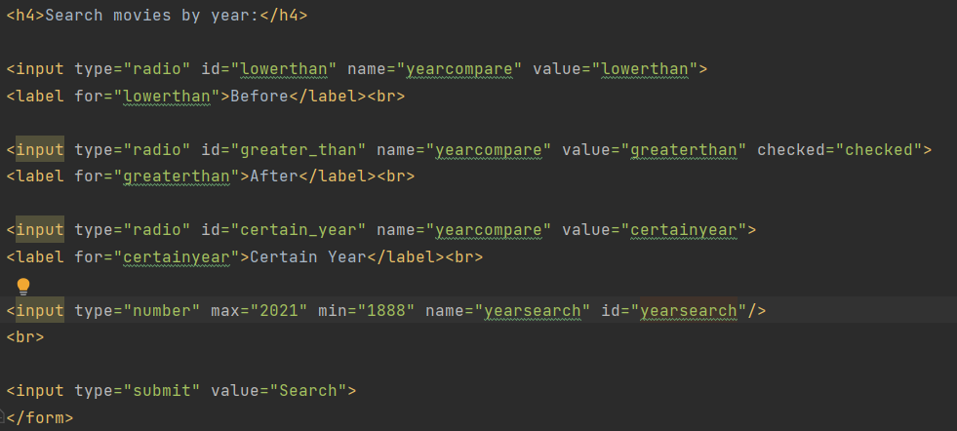
Underline missing

